Studio PDR Planning Worksheet

Learning outcome 1
Select and apply industry-standard tools and processes to solve non-trivial problems in a team environment.

Objectives:
- Select and apply Scrum techniques proficiently to align to the Agile Principles wherever possible.
- Demonstrate professionalism in your use of project management and communication tools.
- Employ leadership in a flat-structured, cross-functional team (e.g. leading by example, champion role).

Learning outcome 2
Analyse and manage development challenges to create production-quality outputs.

Objectives:
- Analyse user requirements and contribute regularly to development of new product features that meet those requirements.
- Participate regularly in code/solution review to ensure high-quality outputs
- Conduct self-directed research to contribute regularly to all technical aspects of the project, including:
  - deployment and CI/CD,
  - quality assurance and testing,
  - security, and
  - user experience.

Name:
Date of scheduled PDR meeting: Mid-semester/ Final
Discussed with:

Please complete the reflective section below to help give us the context for your evidence.

What are your personal goals and objectives in addition to the course objectives?
This could be for Studio, BIT or general career progression

I am trying to improve my communication skills and communicating more out of class through either email or teams.
What has gone well this semester? What are your strengths?

Debugging weird problems. My strengths still lie in doing actual programming though I would have liked to do more coding.
What could have gone better and how? What would you do differently next time?
If you could replay the semester over again, what improvements would you make?

My team communication was lacking and sprint planning was a too ambitious. Swapping to velocity point based planning helped near the end.
Additionally I spent too long helping teammates instead of doing actual coding.
What are the next steps to take? What is your plan for further self-development?

Improve on my teaching skills so I can help my team mates faster so I can get to doing more coding. Teach more.
What barriers to your success exist? How do you plan to deal with them?

Lack of sleep/ Bizarre sleep schedule/ reliance on energy drinks or coffee to stay awake. Also an increase in “brain fog” and headaches as a result.
What is not clear or is uncertain?
In Studio, for BIT, at Polytech etc

If there is a way to skip one studio to graduate this year and if that’s not possible what additional classes to take next year.

Instructions
For each objective, provide enough evidence to show that you have met the requirements.

For every objective include:
- at least one image (if available) for quick reference,
- an analysis of how the evidence proves you’ve met the objective, and
- links to any more evidence that exists for that objective.

  - Select and apply Scrum techniques proficiently to align to the Agile Principles wherever possible.

Evidence guidance: Are you attending stand-up meetings? What Scrum events and artefacts can you show? How do your team’s processes align to the Agile Principles? What suggestions have you personally made to improve your team performance? Are you applying techniques from previous semesters to solve performance problems (e.g. user stories -> user-centric focus; story points -> effective Sprint planning, etc)?

We have primarily used standup meetings and user stories this semester.
Standup meetings helped us the most as it motivated everyone to try and get something done every day.

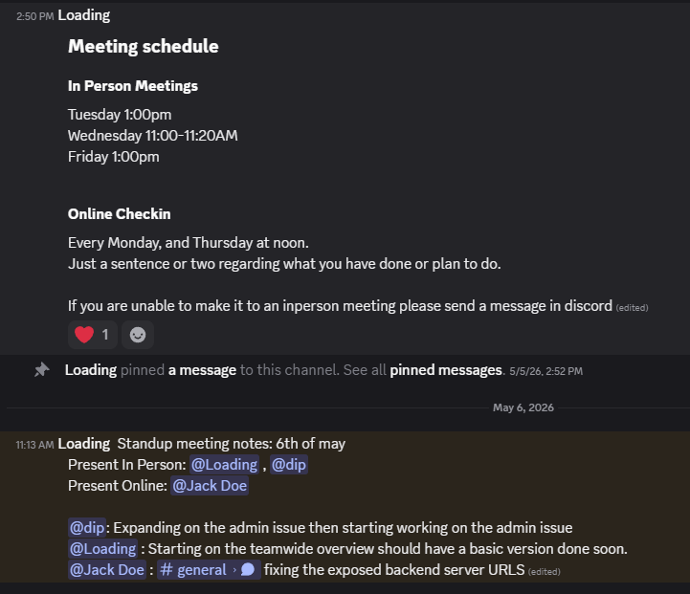

Our daily standup meetings helped clarify what everyone was doing every day let us catch some issues before they spiralled out of control.

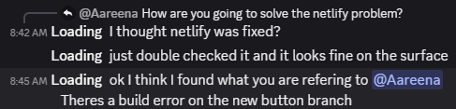

  - Demonstrate professionalism in your use of project management and communication tools.

Evidence guidance: Are you writing thorough descriptions for your issues and pull requests? Do you always update the status of your tickets in a timely manner? Do you use all the features of GitHub to keep everything well-organised? Do you respond to comments from your team mates in a timely manner and with professional tone?

  - Employ leadership in a flat-structured, cross-functional team (e.g. leading by example, champion role).

Evidence guidance: Have you identified problems to be solved in the way your team approaches the aspect you are champion of? Do you lead by example to improve on issues in your team’s performance (e.g. regular communication)? Do you take ownership of challenges and lead the team through the problem-solving process?

  - Analyse user requirements and contribute regularly to development of new product features

Evidence guidance: Have you met with the Product Owner and written User Stories? Have you broken the User Stories down into tickets in the issues list? Have you opened Pull Requests for your assigned tickets and written a description that analyses the problem to be solved, identifies any potential challenges and outlines the approach you intend to take? Do you contribute commits over several days during every Sprint?

  - Participate regularly in code/solution review to ensure high-quality outputs

Evidence guidance: Have you conducted a review of someone else’s PR every Sprint? Can you show at least one example where you helped to improve the quality of the feature with your feedback? Have you written a report that details the current quality of the team or project with regards to your “champion” role and outlined ways to improve that the whole team can follow?

  - Conduct self-directed research to contribute regularly to all technical aspects of the project, including:
  - deployment and CI/CD,
  - quality assurance and testing,
  - security, and
  - user experience.

Evidence guidance: Have you taken your “champion” role seriously, by overseeing that aspect and ensuring everyone in the team contributes (if your role is Scrum Master then you probably answered this in a previous objective)? Have you contributed to all of the aspects listed above in almost every Sprint, in addition to your development work? Have you written tests to go with your code? Have you explicitly checked for security issues and UX issues in code reviews? Have you used the deployment pipeline correctly (e.g. feat. -> staging -> main)? Did you write any automation scripts? Have you employed any specific UX techniques?

